**Database System Assignment**

**Project Requirement Specifications ,ERD and Normalization**



**Session: 2021**

**Submitted by:**

**Wali Muhammad 2021-SE-39**

**Submitted to:**

**Dr. Umer Qasim**

Department of Computer Science, New Campus

**University of Engineering and Technology Lahore, Pakistan**

**Requirement Specifications**

1. **Functional Requirements**

* The system should allow users to register as an admin or salesman and provide secure login functionality.
* Admin should be able to add, update, and delete laptop details such as laptop name, vendor name, price, etc.
* Admin should be able to add, update, and delete salesman details such as name, age, salary, etc.
* Salesman should be able to generate invoices for each sale, which should include details such as customer name, payment amount, product ID, and sales ID.
* The system should allow the admin to view the monthly sales and generate reports that show the total sales for a particular month or year.
* The system should generate reports that show the sales made by each salesman in a given period.
* The system should allow the admin to generate analytics reports such as the best-selling laptop, the highest revenue-generating salesman, etc.

1. **Non-functional Requirements**

* System must be available 24/7
* System must be secure and protect sensitive customer and financial data
* System must be scalable to accommodate growth in the number of users and data volume
* System must be user-friendly and easy to use for salesmen, admins, and customers.
* System must have a fast response time to avoid delays in invoice creation and payment processing.
* The system should have a user-friendly interface that is easy to navigate and understand for all users.
* The system should have proper authentication and authorization mechanisms in place to ensure that only authorized users can access the system and its data.

**ER Diagram**

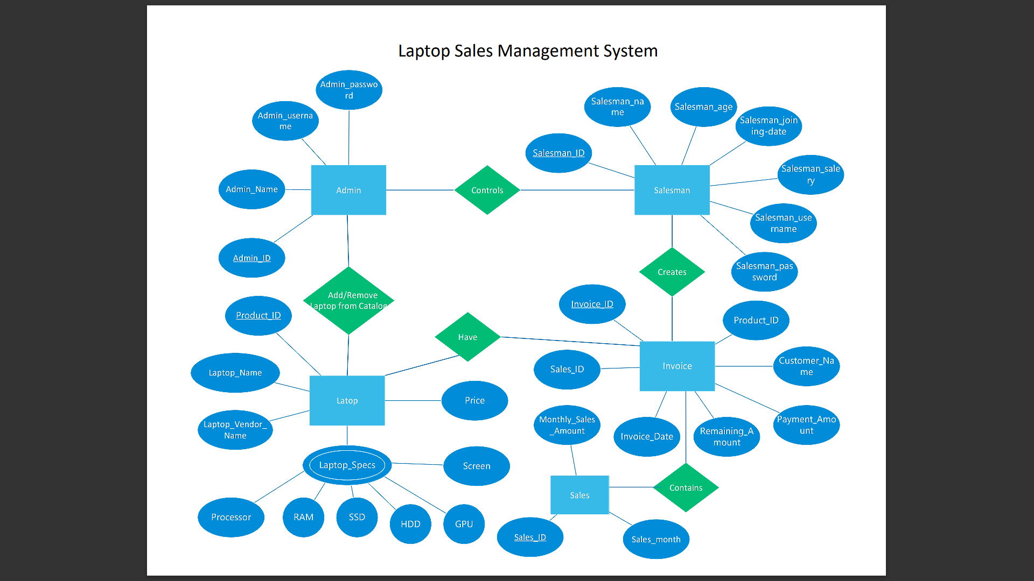

**Normalization**

The normalization forms of all the tables are provided below:

**Admin table**

1NF: The table is already in 1NF, as each column has atomic values and there are no repeating groups.

2NF: The table is already in 2NF, as it has only one candidate key, which is the primary key.

3NF: The table is already in 3NF, as there are no transitive dependencies.

**Salesman table**

1NF: The table is already in 1NF, as each column has atomic values and there are no repeating groups.

2NF: The table is already in 2NF, as it has only one candidate key, which is the primary key.

3NF: The table is already in 3NF, as there are no transitive dependencies.

**Laptop table**

1NF: The table is already in 1NF, as each column has atomic values and there are no repeating groups.

2NF: The table is already in 2NF, as it has only one candidate key, which is the primary key.

3NF: The table is already in 3NF, as there are no transitive dependencies.

**Invoice table**

1NF: The table is already in 1NF, as each column has atomic values and there are no repeating groups.

2NF: The table is already in 2NF, as it has only one candidate key, which is the primary key.

3NF: The table is already in 3NF, as all non-key attributes are directly dependent on the primary key.

**Sales table**

1NF: The table is already in 1NF, as each column has atomic values and there are no repeating groups.

2NF: The table is already in 2NF, as it has only one candidate key, which is the primary key.

3NF: The table is already in 3NF, as all non-key attributes are directly dependent on the primary key.

**THE END**